* **B-days**

**August Birthdays**:

|  |  |  |
| --- | --- | --- |
| Sheila | Coyle | 08/10 |
| Tanya | Carter | 08/15 |
| James | Brustad | 08/15 |
| Marcin | Zgola | 08/17 |
| Kenneth | Birdie | 08/18 |
| Beth | Kirshenberg | 08/19 |
| Kristin | Laverty | 08/26 |
| Diana | Chronis | 08/30 |

The August Birthday Celebration will be on Wednesday August 20th at 2pm in the large conference room on the 5th floor.

* **LaSalle Anniversaries**

|  |  |  |
| --- | --- | --- |
| David | Hackman | 8/01/1986 |
| Misty | Thomas | 8/01/2007 |
| Elias | Savanhu | 8/13/2013 |
| James | Brustad | 8/20/2007 |
| Karen | Brewer | 8/25/1997 |
| Gary | Sloas | 8/30/2010 |

* **LaSalle Special Anniversaries**

|  |  |  |
| --- | --- | --- |
| Karen | Hansen | 8/24/2004   - 10 years!!! |
| Marcela | Melendez | 8/28/2004  - 10 years!!! |

* **LaSalle Announcements**

E-original – Lease Administration is pleased to announce the completion of their first electronic transaction. We are excited about the new service that we can provide. Some of the benefits to this “paperless” process include – improved turnaround time, quicker booking and funding.

Congrats - LaSalle Solutions, announced it has been named to the 2014 Solution Provider 500 (SP500) list by The Channel Company’s [CRN](http://www.crn.com/). The list ranks the top revenue-generating technology integrators in the U.S. and Canada whose forward-thinking approach to the channel has helped them evolve and thrive in today’s cloud and services-driven IT era.  The list spans eight categories from hardware and software sales, to managed IT services. LaSalle Solutions placed #102 in the annual ranking.

Great news!! LaSalle Solutions is once again on Monitor 100 List (published by Monitor Daily) – this year we are #93, up from #95 last year. You can see the release on our website at [www.elasalle.com/news](http://www.elasalle.com/news) .  The Monitor 100 is the only source of its kind that provides a total dimensioning of the largest equipment finance and leasing companies in the U.S.

Monitor Daily also publishes segment listings (ie, Top Banks, Top Captives, Top Independents).While LaSalle operates very much as an “Independent”, since we are not “privately owned”, we are not included in the Top Independents listing. But . . . if we were, we would be ranked 18th for 2013 (up from 20th the year before).

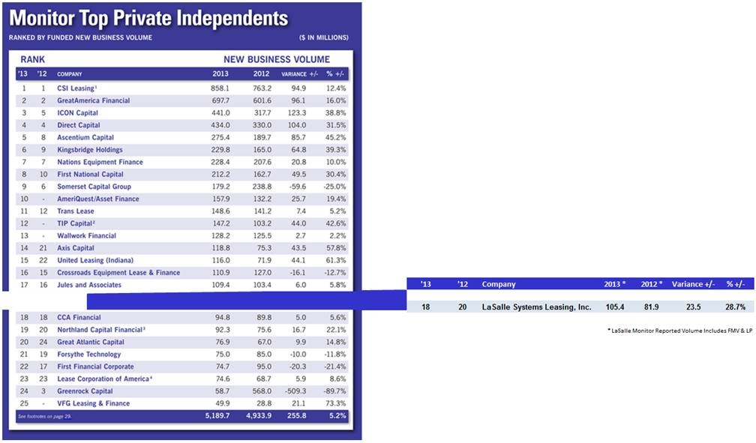

* **LaSalle Events**

LaSalle and Violin are Sponsoring the Technology Executives Club IT Leaders Circle August 21, 2014 in Lake Forest, IL. This event will be attended by IT leaders from around the Chicagoland region will provide insights into management of evolving technology opportunities.  LaSalle and Violin will have a booth during the event, and an executive from Violin will moderate the last panel discussion of the day - “Strategic Partnering with the Business". This valuable event is open to all Director Level and above technology executives.  Please invite your contacts to attend!!

Employees at the Rosemont Branch held a Bon-Voyage Brunch for Bob as he sailed off to his annual Mackinac trip. Thank you to the all those participated and signed up to cook or bring in a treat for all to enjoy.

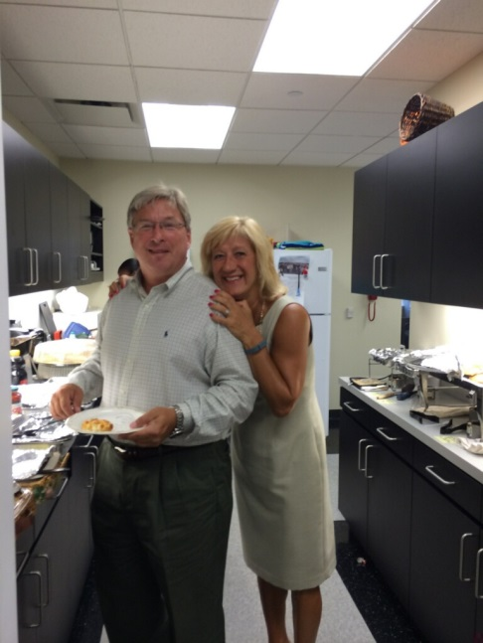

* **LaSalle Holiday Schedule – 2014**

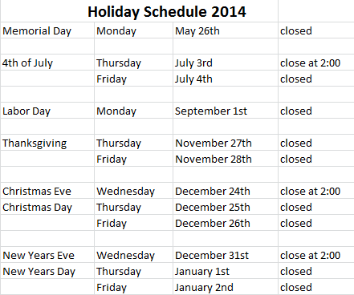

**Kudos Korner -- Kudos to LaSalle:**

**From: Randy - LeaseTeam**   
Sent: Friday, July 18, 2014 8:21 AM  
To: Metzen, Bob  
Cc: Brustad, James  
Subject: Great Company....Great results!

Bob and James,

I love seeing our customers and good friends continue to do well over the years and get acknowledged by the Monitor as one of the top 100 companies in our industry. To be honest probably one of the better run over the years as well, and probably have been in the top 100 for many years.

Congratulations to you and your team for your continued success. It’s a pleasure to have worked together with you and your great team over all these many years. It’s a relationship that means a lot to LeaseTeam and to me personally.

Onward and Upward!

Randy

**From: Jeff – LeaseTeam**

Sent: Friday, July 18, 2014 8:32 AM  
To: Brustad, James  
Subject: FW: Southeast Capital Names Quiriconi Head of Transportation Finance

Hey James…Hope all is well!  Congrats on another year in the Monitor 100…that is fantastic!!!

*Friendly reminder – if you’d like to send a “shout out” to someone kindly email –* [*newsletter@elasalle.com*](mailto:newsletter@elasalle.com)

* **Training and Personal Development:**

Team LaSalle - here is a great article on the values of a good team: <http://www.ronedmondson.com/2014/07/7-non-negotiable-values-for-teams-i-lead.html>

* **Special events:**

Save these dates:

Tuesday August 5th – we will be celebrating the 10 year LaSalle anniversaries of Steve Robb (7/30), Karen Hansen (8/24) and Marcela Melendez (8/28). Food and cake will be brought in, please mark your calendars and plan on celebrating with us.

Wednesday August 27th – this is our tentative date for an “end of summer backyard BBQ”. Plan on joining us from 4-7 as we will be grilling out, playing games, and enjoying some fun together.

* **Reminders :**

Month end & AP closes – August 28, 2014

* **Quotable Quote:**

Too often we enjoy the comfort of opinion without the discomfort of thought.

-- John F. Kennedy, 35th U.S. president

* **Did you know:**

Employee Guess Who-

This LaSalle Team member was born in Evanston, so he has some Chicago roots…and has two places to call “home”. A drummer through high school who “sang in a rock and roll band”, he learned years later that the voice microphone was never turned on - - - and that “the girls” all used to run after the band van when they were leaving their gigs – if only he’d known!! Pictured here . . . you can see that his future was clear at a young age . . .



*Friendly reminder – if you’d like to see something featured in the “Did you know” section – kindly email –* [*newsletter@elasalle.com*](mailto:newsletter@elasalle.com)

* **I.T Update:**

